Ideation Phase
Empathize & Discover

Date | 31 January 2026
Team ID | LTVIP2026TMIDS52445
Project Name | Prevent User Deletion If Assigned to an Incident in ServiceNow
Maximum Marks | 4 Marks

Empathy Map Canvas:

👤 User Persona
Role: ServiceNow Administrator
Goal: Maintain data integrity and proper incident ownership

🧠 Thinks
- I must ensure no incident loses its assigned owner
- User deletion should not break references
- The system should validate dependencies automatically
- Manual checking is risky and time-consuming

👀 Sees
- Users being deleted while incidents are still active
- Orphan incident records without assigned users
- Increased audit and tracking issues
- Lack of built-in deletion safeguards

👂 Hears
- “Incident owner is missing” from service desk team
- Complaints about lost accountability
- Requests for better data validation controls
- Management asking for audit compliance

🗣️ Says & Does
- Checks incident records before deleting users
- Advises team not to delete assigned users
- Performs manual verification steps
- Looks for automated solutions in ServiceNow

😣 Pain Points
- Manual dependency checking takes time
- Risk of accidental deletion
- Broken workflows and reporting errors
- Loss of accountability in incident tracking

🎯 Gains
- Automated validation before user deletion
- Prevent orphan incident records
- Maintain ITSM best practices
- Improve data consistency and reliability
- Reduce manual effort

Example:
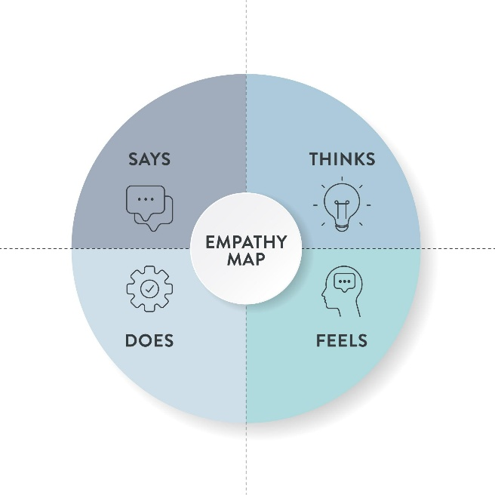

Use Case: ServiceNow User Deletion Validation

👤 User
ServiceNow Administrator

🧠 THINKS
- I need to maintain data integrity in the system
- Deleting users should not affect active incidents
- There must be an automated safeguard

👀 SEES
- Users being deleted while still assigned to incidents
- Incidents without owners
- Audit and tracking issues

👂 HEARS
- “Who is responsible for this incident?”
- Complaints from service desk team
- Management asking for proper accountability

🗣️ SAYS & DOES
- Manually checks incident assignments before deletion
- Warns team not to delete assigned users
- Searches for a system-level solution

❤️ FEELS
- Frustrated due to manual work
- Worried about data loss
- Responsible for maintaining system reliability

🎯 GAINS (Expected Solution Outcome)
- Automated validation before user deletion
- No orphan incident records
- Improved workflow continuity
- Better audit compliance

